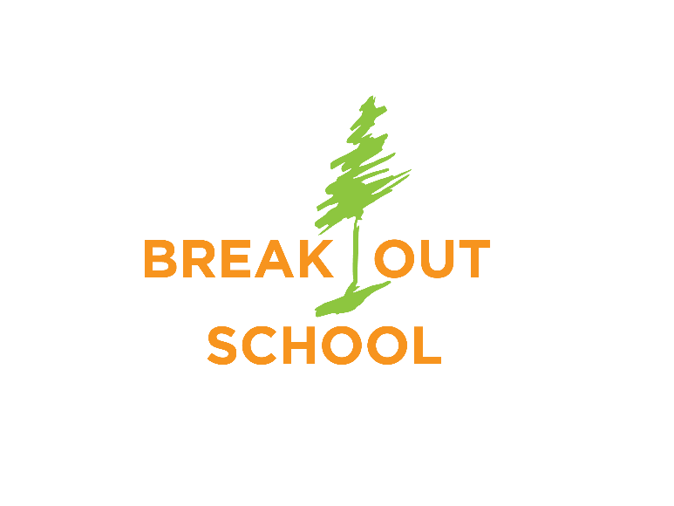
PARENT RE
PARENT
RE
Break Out of Limits – Break into Real World Learning

Day Camp Admission Parent Questionnaire
Child’s name:
__________________________________________________________Sex:__________
Application date: __________________________________Grade for 2022-23_________
Camp Session(s) Requested
Session 1, June 25th 2022 Payson Canyon (Kiwanas Park)
- How did you learn about BreakOut School?

Does a friend deserve a 50% tuition discount for referring you? Yes No If so, whom?
2. How has your child adjusted to other school or camp experiences?

3. Describe any specific fears or anxieties your child may have:
4. How does your child express frustration or anger? How do you respond?
5. What do you consider your child’s most outstanding characteristics?

6. Describe any physical, emotional, or social areas in which your child needs support:
7. Has your child ever been evaluated by a psychologist, psychiatrist, or counselor for issues associated with behavioral issues? If so, please describe the circumstances and attach related reports (letter/report from health care provider).
8. Is your child on medication? Yes______ No______ If Yes, please list types and dosage. Medication:_____________________________________Dosage:___________________
Medication:_____________________________________Dosage:___________________
Medication:_____________________________________Dosage:____________________
9. Please list any chronic health conditions your child has along with limitations on activities:

10. Please list any allergies to the environment (mold, pollen, insects), food, or medication that your child has along with limitations on activities.
I attest that all information I provided is true.
Parent Signature_______________________________________________ Date ______________ Send this completed questionnaire, application and camp fee ($75) to:
BreakOut School 1088 W. North Star Circle, Layton UT 84041
Or scan and send to BreakOut@BreakOutSchool.org Venmo camp fee ($75 per session) to: BreakOutSchool @BreakOutSchool

BreakOut School reserves the right to be selective about students admitted to our school in order that all can learn in a safe environment. Students who have behavioral issues such as bullying, violence, abusive behavior, running away or significant resistance are not appropriate for BreakOut School.

NOTICE OF NONDISCRIMINATORY POLICY AS TO STUDENTS The BreakOut School admits students of any race, color, national and ethnic origin to all the rights, privileges, programs, and activities generally accorded or made available to students at the school. It doesn't discriminate on the basis of race, color, national and ethnic origin in administration of its educational policies, admissions policies, scholarship and loan programs, and athletic and other school-administered programs

