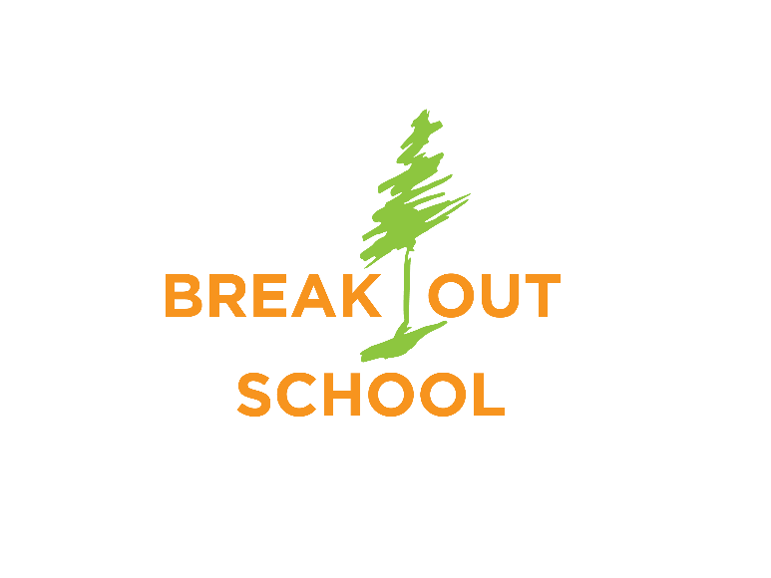
PARENT RE
Refer a friend for a 50% discount
Adventure Camp for ADHD Boys

Break Out of Limits – Break into Real World Learning

These day-camps are specifically tailored for ADHD boys entering grades 4-8 in Spring 2021. They are located outdoors and occur from 9am-3pm for 2 days
This is for a VERY small group: Only 10 boys total per session!

Session 1: March 19-20 Payson Canyon
Session 2: April 23-24 Hobble Creek Canyon

Each Camp Features:

• Wilderness survival techniques
• Wilderness First Aid
• Plant and animal identification
• Tracking humans
• Supervision by 1-3 background-checked adults at all times
• Hunting and Trapping techniques in history
• Social interaction/friendship building
• Behavior accountability program with personal feedback
• Archery, Gun Safety
• Cooking exotic meats over a fire
• Dutch Oven Cooking with campfires--And more!
• $250 per session, with 50% discount if you refer a friend!
Go to BreakOutSchool.org for more details and an application!
BreakOut School qualifies as “Lowest Risk” per CDC guidelines

NOTICE OF NONDISCRIMINATORY POLICY AS TO STUDENTS The BreakOut School admits students of any race, color, national and ethnic origin to all the rights, privileges, programs, and activities generally accorded or made available to students at the school. It doesn't discriminate on the basis of race, color, national and ethnic origin in administration of its educational policies, admissions policies, scholarship and loan programs, and athletic and other school-administered programs.

