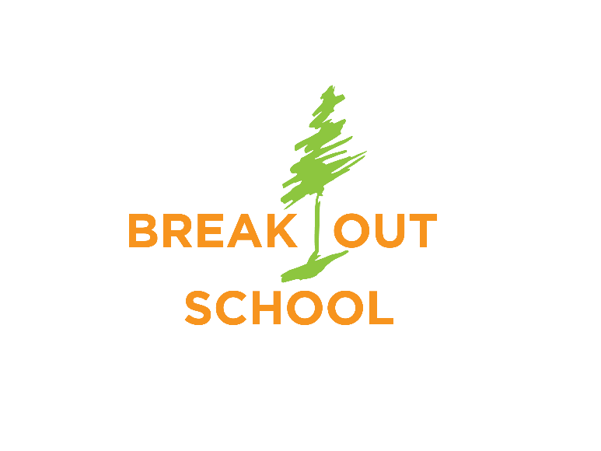
PARENT RE
Hurry! Discount Expires July 20
Adventure Camp for ADHD Boys

Break Out of Limits – Break into Real World Learning

These day-camps are specifically tailored for ADHD boys entering grades 4-8 in Fall 2019. They are located outdoors and occur from 9am-3pm for 3 days in a row. This is for a VERY small group: 6 boys total per session!

Session 1: July 25-27 Hobble Creek Canyon
Session 2: July 31-August 2 Payson Canyon
Session 3: August 7-9 Provo Canyon

Each Camp Features:
- Horseback riding
- Bike riding
- Wilderness survival techniques
- Plant and animal identification
- Tracking humans
- Archery
- Supervision by 2-4 background-checked adults at all times
- Water activities
- Social interaction/friendship building
- Behavior accountability program with personal feedback
- Cooking with campfires
- And more!
- Introductory rate only $300 per session until July 20th!
    - (after that, the price increases to $400)
Go to BreakOutSchool.org for more details and an application!

